**Name:** Jayden Long **ID:** 6844191

**MEDSCI 309 Numeric Problems:**

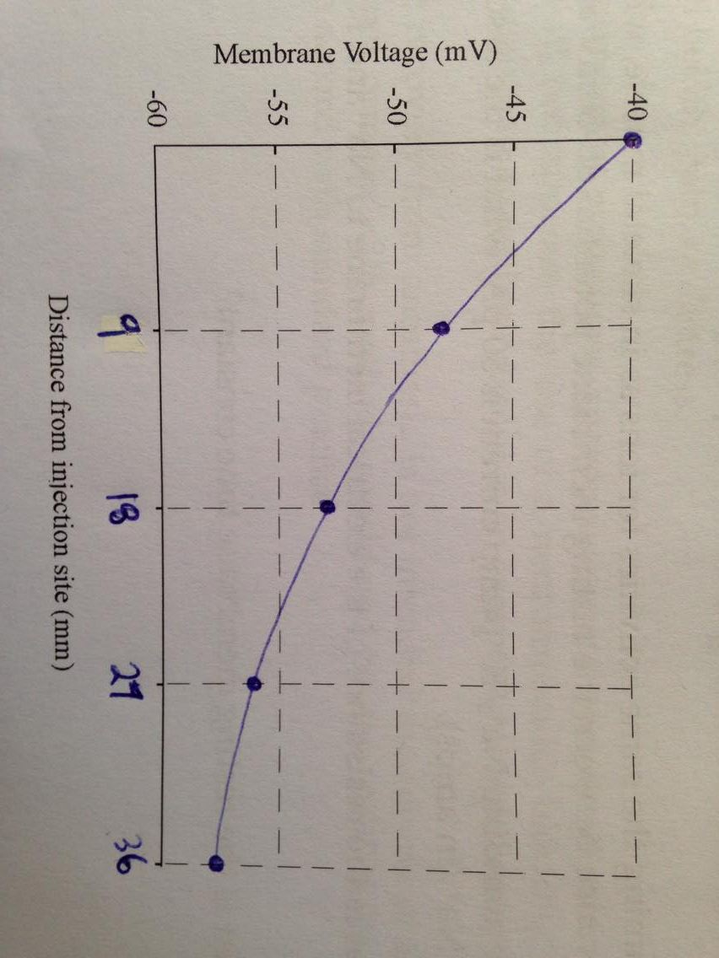

3.a)



b) i.

The distance at 37% of V0 coincides with the membrane length constant (λm) (REFERENCE). This corresponds to -57.5 + (-40-(-57.5)) x 0.37 which as shown on the figure to the left is -51.025 mV. Drawing a line across to the curve and then down to the x axis gives us an estimate of λm.

λm = 13.5 mm

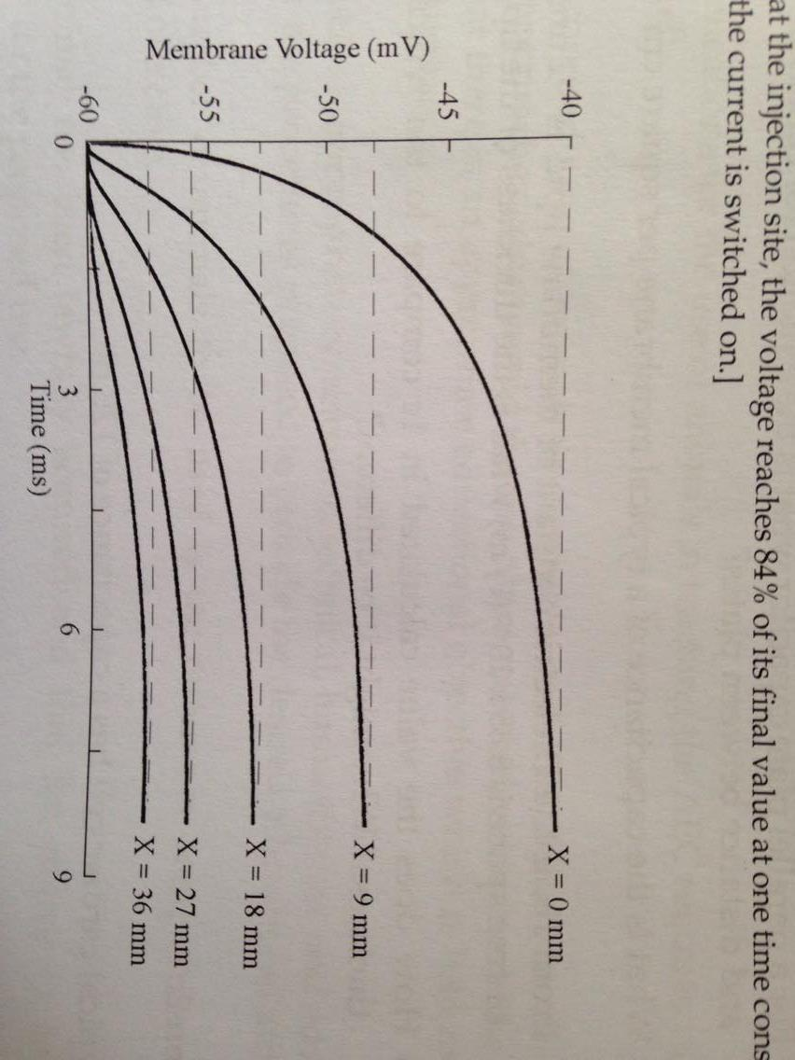ii.

The distance at 84% of V0 (line where X = 0 mm) coincides with the membrane time constant (τm) (REFERENCE). This corresponds to -60 + (-40-(-60)) x 0.84 which as shown on the figure to the left is -43.2 mV. Drawing a line across to the curve and then down to the x axis gives us an estimate of τm.

τm = 3 ms

c) From (REFERENCE) : τm = RmCm  so τm/Cm = Rm

where Cm = 0.01 µF/mm2 and τm = 3 ms

Rm = 3 x 10-3 / 0.01 x 10-6 = 300000 s·mm2/F where 1 F/s = 1/Ω

so Rm = 300000 Ω·mm2 or 300 kΩ·mm2

d)

a = 300000 / (2π x 137200)

a = 0.348 mm

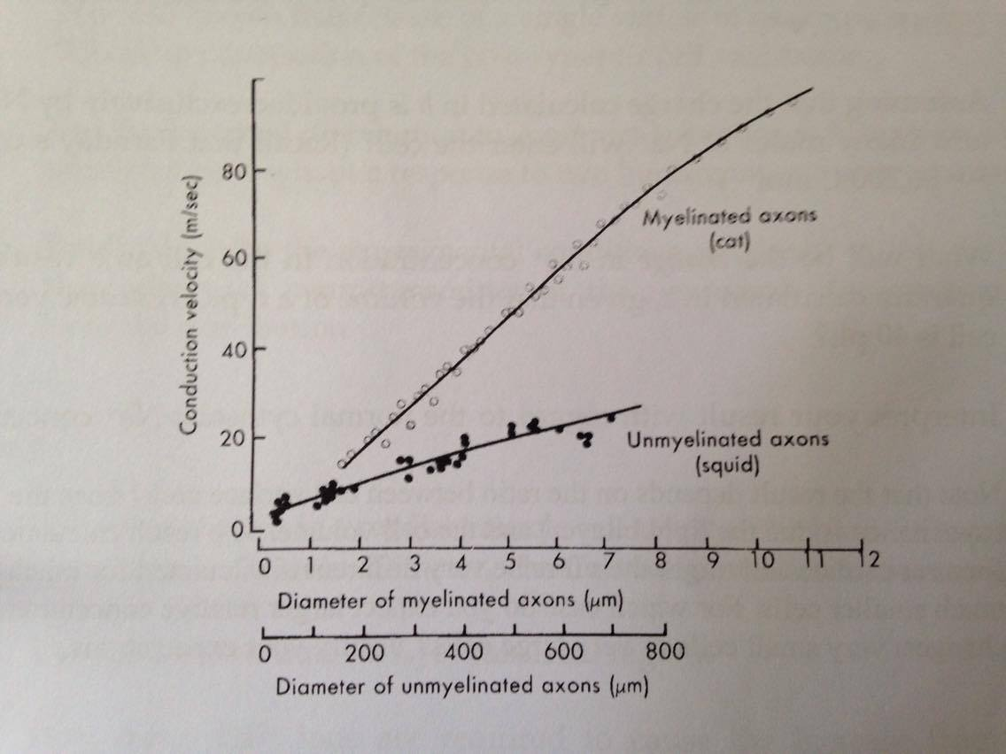Now that ‘a’ has been found we can multiply it by 2 to get the diameter which is 0.696 mm or 696 µm. Then we can use the graph below to estimate the velocity at this 696 µm by drawing a line up from the x axis to the trend line and then across to the y axis (representing velocity).

From the graph on the left it can be estimated that the velocity of conduction of the action potential in this nerve is:

θ = 22 m/s